OOP Lab Practical – 2

Name: Divyam Kumar

SAPID: 500083141

Roll No: R214220434

Batch: B2

**Title: To understand basic data types, conditional logic, loops, in java programming.**

1. Write and execute my first java program.

2. Write a program to print Fibonacci series using java loop. (up to 10 numbers)

3. Write a program to find the largest of 3 numbers.

4. Write a program to find the sum of all integers greater than 40 and less than 250 that are divisible by 5.

Question 1:

**ALGORITHM:**

Step 1 -> Start

Step -2> Display “Hello User”

Step 3-> Display “Divyam Kumar”

Step 4-> Display “500083141”

Step 5-> Stop

**CODE:**

class First

{

public static void main(String args[])

{

System.out.println("Hello User");

System.out.println("Divyam Kumar \n 500083141");

}

}

**OUTPUT:**

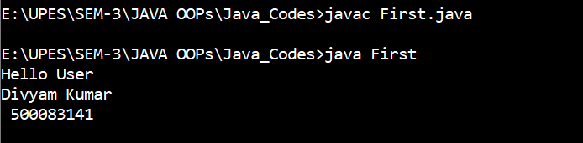

Question 2:

**ALGORITHM:**

Step 1 -> Start

Step 2-> Initialize a=0, b=1 and c as integers

Step 3-> Display a and b

Step 4-> C=a+b

Step 5-> Display c

Step 6-> Set a=b and b=c

Step 7-> Repeat steps 4 to 6 ‘n’ times

Step 8-> Display “Divyam Kumar”

Step 9-> Display “500083141”

Step 10-> Stop

**CODE:**

class Fibo

{

public static void main(String args[])

{

int a=0,b=1,c,n=10;

System.out.print(a + " ");

System.out.print(b + " ");

for(int i=2;i<n;i++)

{

c=a+b;

System.out.print(" " + c);

a=b;

b=c;

}

System.out.println("\n Divyam Kumar \n 500083141");

}

}

**OUTPUT:**

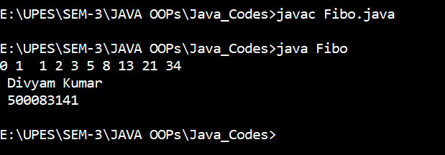

Question 3:

**ALGORITHM:**

Step 1: Start

Step 2: Declare variable a, b, c

Step 3: check if a>b and also a>c

1-if true print a is largest

2-if false go to step 4

Step 4. check if b>a and also b>c

1-if true, print b is largest

2-if false, print c is largest

Step 5: Display “Divyam Kumar”

Step 6: Display “500083141”

Step 7: Stop

**CODE:**

class Greatest

{

public static void main(String[] args)

{

int a=10,b=14,c=9;

if(a>b&&a>c)

{

System.out.println("a is the greatest number:"+a);

}

else if(b>a&&b>c)

{

System.out.println("b is the greatest number:"+b);

}

else

{

System.out.println("c is the greatest number:"+c);

}

System.out.println("Divyam Kumar \n 500083141");

}

}

**OUTPUT:**

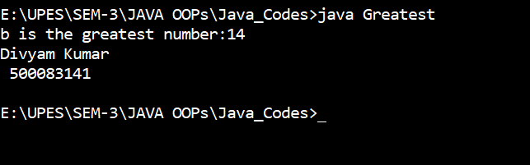

Question 4:

**ALGORITHM:**

Step 1- Start

Step 2-initialise sum=0 and i as integer

Step 3- For i>40 and i<250

1. If true, proceed
2. If False, print sum and go to step 6

Step 4- check if i is divisible by 5

1. If true, sum=sum+i and i=i+1
2. If false, Go to the step 3

Step 5- Print Sum

Step 6 - Display “Divyam Kumar”

Step 7 - Display “500083141”

Step 8 - Stop

**CODE:**

class Sum

{

public static void main(String[] args)

{

int i;

int s=0;

for(i=41;i<250;i++)

{

if(i%5==0)

s=s+i;

}

System.out.println("Sum of Integers divisible by 5:" + s);

System.out.println("Divyam Kumar \n 500083141");

}

}

**OUTPUT:**

